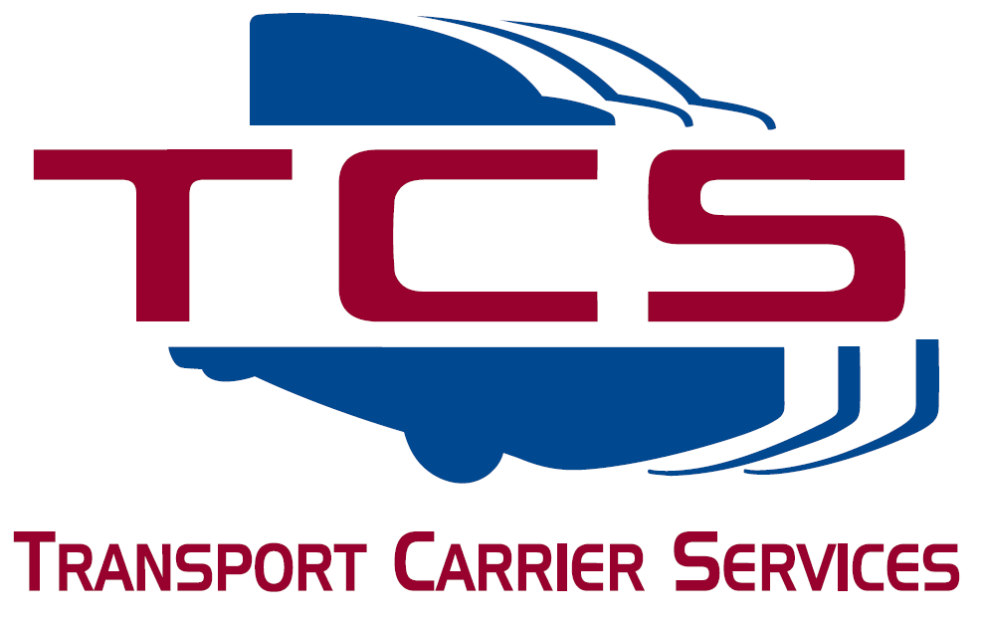
TRANSPORT CARRIER SERVICES

P O Box 14650

Phoenix AZ 85063
Please verify all pre-printed information

Phone: 623-937-9869 ext 210 Fax: 623-934-4548
Toll Free: 877-243-8827
E-Mail: Authority@TCSPhoenix.com

2024 UCR & PERMIT RENEWAL

ALL MOTOR CARRIERS, FREIGHT FORWARDERS, BROKERS & PRIVATE CARRIERS ARE REQUIRED TO HAVE THE UNIFIED CARRIER REGISTRATION (UCR).
Company Name: |  | #:

What commodities do you haul?
2023 UCR (Unified Carrier Registration) expires on December 31, 2023. 2024 UCR renewals will be starting NOW! To assure an accurate and timely renewal of your 2024 credentials please return this renewal form as soon as possible. IF YOU WERE REQUIRED TO HAVE PRIOR YEARS UCR AND HAVE NOT DONE THEM, THEY WILL NOT ISSUE YOUR 2024 UCR.
Please read all notes and directions carefully. If you have any questions, please feel free to give us a call.
INFORMATION NEEDED FOR RENEWAL:
- Please provide an equipment list of vehicles and trailers that are in your fleet. You may attach a second sheet if necessary. If you make a separate list, be sure to include all information. Do not assume that TCS knows what vehicles you need renewed.
- Which operation(s) applies to your company (complete all that apply):
FOR HIRE MC#: |  | MC TYPE:
US DOT #:
F E I #: |  | Private Carrier (Not for Hire):
BASE STATE: |  | Exempt (Produce Only):
- Please list ALL TRUCKS AND TRAILERS operating under your DOT#.
Unit # | Year | Make |  | Unladen Weight | Gross Weight | Axles | VIN # |  | IRP Plate #
Equipment: |  |  | # of Straight Trucks |  |  | # of Truck Tractors |  | # of Trailers
Owned:
Leased:
Operated Interstate:
Operated Intra-State:
MILEAGE PERMITS
Please list unit #s in states you need permits.
New Mexico
_________
_________
_________
_________
_________

Please note: Incomplete applications will not be processed. They will be returned to you for completion and could affect the timeliness of your UCR renewal. They are processed in the order they are received in our office.
Billing will be generated from this form and your credentials will be ordered when your payment is received in our office.

PRINT NAME:____________________________________________________DATE: _________________________

SIGNATURE:_____________________________________________________________________

